Renju lesson on February 14, 2002

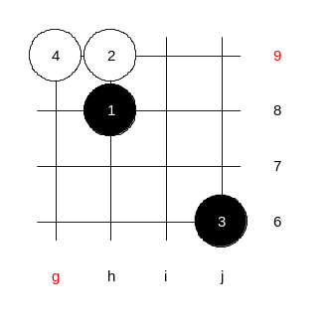
Hello everyone! Welcome to Online Renju Class. Happy Valentine’s Day to everyone. Are you ready for the lesson? Good. Do you know today’s opening? Today’s opening is d13 that was chosen by the majority of students. D13 is considered to be white win. However, I am not sure how many of you know it. Today, I cannot be 100% sure myself either. I am sure, most of you would lose the game as white in d13 without having the serious preparation. The knowing that there should be white “win” doesn’t help if we don’t study it, right? About the 4th moves, we have two choices – g8 and g9. Which one you want to check first? Move g9 is more practical for study. You know why? Because it will lead to i13, and we can study both of them at the same time. It is like beating two flies with one hit. Since it is “white advantage”, we cannot speak of two 5th moves here, but all.

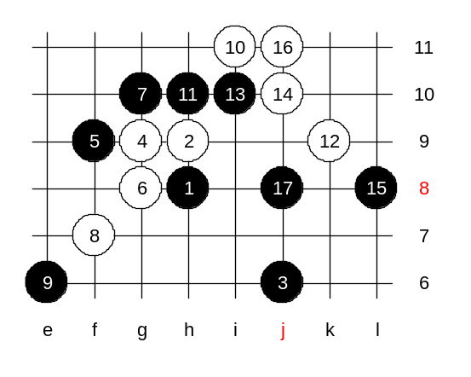
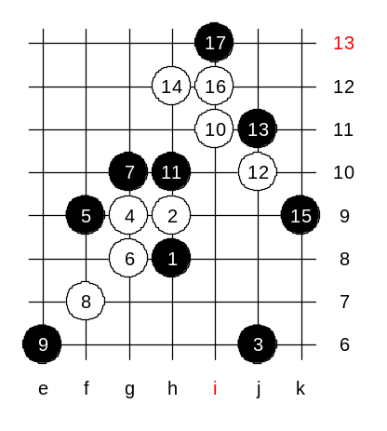
Move 5-f9 seems rather weak. Why? I agree with those who say that black cannot connect its stones and that makes the j6 stone useless. If the j6 stone was at i6, then it would become a big black advantage. One small shift can change a lot in renju. Well, anyway the black’s goal is to make the j6 stone useful while white’s goal is to paralyze j6. Move 6-g8 serves that purpose. White wants black to die in this variant without ever getting a chance to do anything with j6 stone. Now, black has two blocks – g7 and g10. OK, we try upper 7th first. White plays a three. Which side is forced? Yes, lower. White plays 10-i11. Typical development. The same move is used in i12 opening. Move 11-h10 is one of the strongest perhaps. Wow, we faced the failure of white attack in our first attempt. We need to try other ways. Suddenly the j6 stone became useful, and black reached its goal first.

We try another way, but it fails too.

We try the last time today. Then we will continue next week.
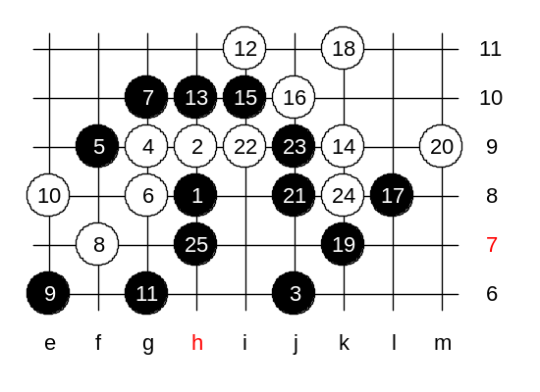
A new style!! How about that?

After 10-e8, we do not need to worry about white’s VCT because black has nothing. So, we just continue naturally – g6. And white plays j11 as before. Black plays the traditional response.
The way we improvised here, turned out to be black win. White should change something earlier.
We will continue analysis next week.
Welcome all to join the off-lesson analysis in the next room right after this lesson.

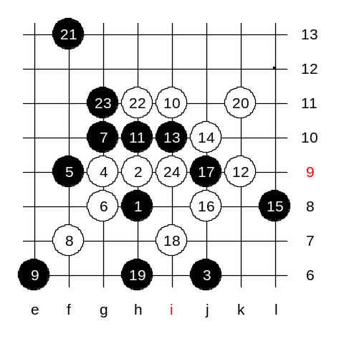
Here are the examples of the off-lesson analysis:
White wins.

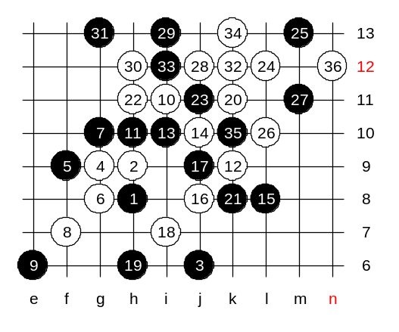

…and wins.

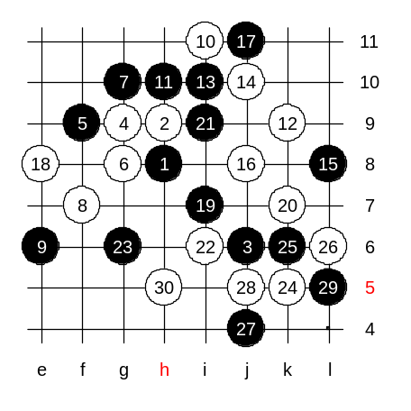

This 17th is strong. The following moves are improvisation.
Outcome: about equal.

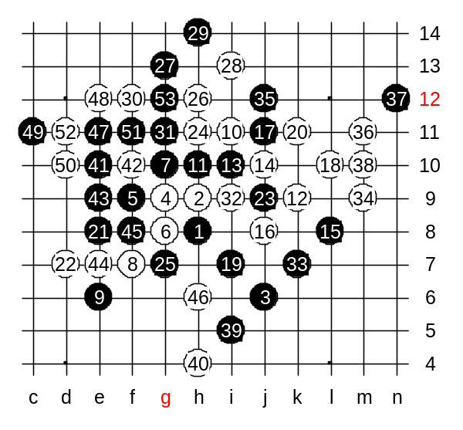
Here, black wins!
Amazing variant!!
Almost seemed like white win, but beautiful 25-g7 and 29-h14 bring black win.
I guess, white should change something earlier, but keep the same principle of active and open game.

